SmartTrap v1.0
Hardware Assembly Guide

1. System Overview
The SmartTrap is an automated monitoring system designed to detect and count Fall Armyworm moths entering pheromone traps. It uses dual-pair infrared beam-break detection (4 LEDs + 4 receivers on D6 and D0) in a star pattern for maximum sensitivity, records JPEG image evidence, and provides wireless data access via Bluetooth.

Key Features
- Automatic moth detection via 4 IR beam-break sensors (2 pairs on D6 + D0, star pattern)
- 10-frame JPEG burst capture per detection event
- Environmental sensors removed in this build to free D0 for IR LED pair #2
- Detection logging with CSV format (environmental sensors not installed)
- SD card data logging with CSV format
- BLE removed in firmware v1.5 (frees memory for camera)
- Scheduled sleep mode for extended battery life
- Password protection for data security

2. Required Components
Component | Specification | Qty | Cost
Microcontroller | XIAO ESP32S3 Sense | 1 | $15
Expansion Board | XIAO Sense Camera/Mic Board | 1 | $10
LCD Display | 16x2 I2C LCD (0x27 or 0x3F) | 1 | $5
Real-Time Clock | DS3231 RTC Module | 1 | $8
IR LED | 940nm IR Emitter (5mm), 2 pairs | 4 | $1
IR Receiver | TSOP38238 IR Receiver (38kHz, 940nm) | 4 | $1
DHT11 (REMOVED) | Not installed — pin D2 free | 1 | $3
DS18B20 (REMOVED) | Not installed — pin D1 free | 1 | $5
Soil Moisture (REMOVED) | Not installed — pin D0 used for IR | 1 | $3
Push Button | 4-pin Tactile Switch | 1 | $1
SD Card | MicroSD FAT32 (≤32GB) | 1 | $8
Resistors | 100Ω (x4 for IR LEDs), 2.2kΩ (x2 for I2C) | 1 each | $0.30
Power Bank | USB 10,000-20,000mAh | 1 | $15-25
TOTAL |  |  | ~$75-90

3. Pin Configuration
XIAO Pin | GPIO | Connection | Notes
D0 | GPIO1 | IR LEDs #3+#4 via 100Ω each | 38kHz PWM output (parallel)
D1 | GPIO2 | Free (future sensor) | Available
D2 | GPIO3 | Free (future sensor) | Available
D3 | GPIO4 | Button → GND | INPUT_PULLUP (no external resistor)
D4 | GPIO5 | I2C SDA (LCD + RTC) | Shared I2C bus
D5 | GPIO6 | I2C SCL (LCD + RTC) | Shared I2C bus
D6 | GPIO43 | IR LEDs #1+#2 via 100Ω each | 38kHz PWM output (parallel)
D7 | GPIO44 | All 4 IR Receivers OUT (parallel) | INPUT_PULLUP, no external resistor
D8-D10 | GPIO7,8,9 | Free (future SIM7670G cellular) | Reserved for cellular
IMPORTANT: Pins D8, D9, D10 (GPIO 7, 8, 9) are reserved for future SIM7670G cellular module. SD card uses internal B2B connector's SD card slot.
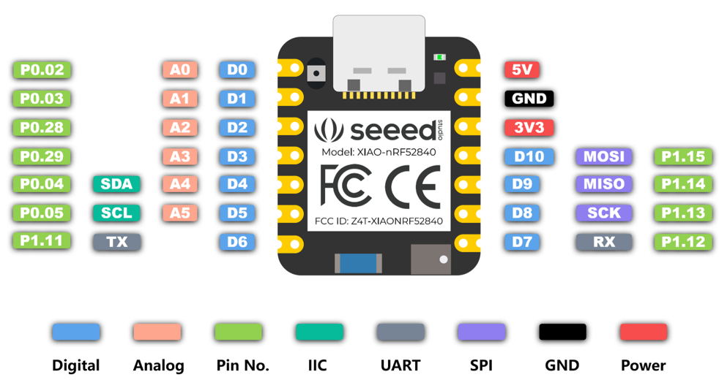

4. Wiring Connections

Power Distribution
- 3.3V → All 4 IR Receivers, RTC, LCD
- 5V → LCD if needed (some work on 3.3V)
- GND → All sensor GND pins (common ground)

IR Beam-Break Sensor
- IR LEDs #1+#2: Anode (+) → 100Ω resistor → D6 (GPIO43), Cathode (-) → GND. IR LEDs #3+#4: Anode (+) → 100Ω resistor → D0 (GPIO1), Cathode (-) → GND. Each LED must have its own 100Ω resistor.
- All 4 IR Receivers: VCC → 3.3V, GND → GND, all 4 OUT pins connect to D7 in parallel (logical OR). Any beam break triggers the interrupt.
- No external pull-down needed. Use INPUT_PULLUP in firmware. Position beam pairs in a star pattern across the funnel opening for maximum coverage.
- Each LED-receiver pair faces each other, 2-10cm apart. Arrange 4 beams at ~45° intervals across the funnel.

IR LED Pairs Wiring Detail
- D6 pair: LED #1 anode → 100Ω → D6, LED #2 anode → 100Ω → D6. Both cathodes → GND.
- D0 pair: LED #3 anode → 100Ω → D0, LED #4 anode → 100Ω → D0. Both cathodes → GND. Both pins output 38kHz PWM simultaneously.

I2C Bus (LCD + RTC)
- LCD SDA + RTC SDA → D4 (GPIO5)
- LCD SCL + RTC SCL → D5 (GPIO6)

5. Verification Checklist
- ☐ SD card inserted and formatted FAT32
- ☐ Expansion board attached (audible click)
- ☐ No shorts between 3.3V and GND
- ☐ Each of 4 IR LEDs has its own 100Ω resistor (Brown-Black-Brown)
- ☐ LEDs #1+#2 wired to D6, LEDs #3+#4 wired to D0 (100Ω each)
- ☐ All 4 IR Receiver OUT pins connected to D7 (parallel, INPUT_PULLUP)
- ☐ Button wired D3 → GND (INPUT_PULLUP, no external resistor needed)
- ☐ D8-D10 pins free for future cellular module
- ☐ 4 IR beam pairs arranged in star pattern across funnel (2-10cm gap each)
Tip: Use a phone camera to verify the IR LED is working - it will appear as a faint purple glow.

